CM work summary_for_bringup_Wang Long
- Code management
  - Git
分布式版本控制系统. 参考 http://git-scm.com/book/zh/%E8%B5%B7%E6%AD%A5-%E5%88%9D%E6%AC%A1%E8%BF%90%E8%A1%8C-Git-%E5%89%8D%E7%9A%84%E9%85%8D%E7%BD%AE
- 安装：sudo apt-get install git-core
- 升级
增加ppa
sudo apt-add-repository ppa:git-core/ppa
sudo apt-get update
sudo apt-get install git
如果本地已经安装过Git，可以使用升级命令：
sudo apt-get dist-upgrade
- .gitconfig文件的配置
- user.name/email/
- customer setting
- url重定向
- GIT的开发使用流程图 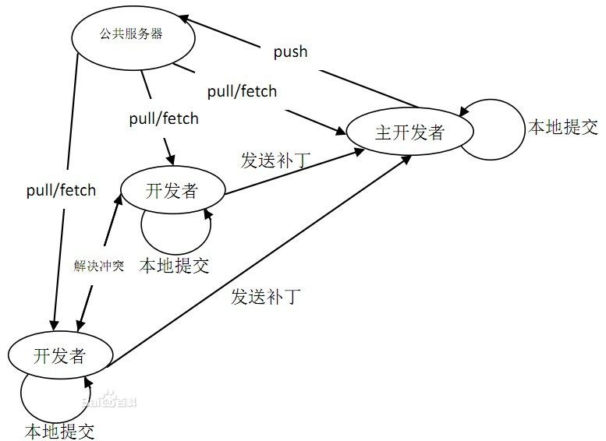
    - Git basic
本结构以从开始拿到code开始，然后本地修改，提交...
因为git一般都是命令操作，所以本文也都是以命令来罗列的。
git clone
example:
git clone ssh://wanglong@192.168.1.121:29418/sony/platform/manifest
# 需要把用户的id_rsa.pub添加到server的authorized列表中，才能获得读写权限

git clone git://192.168.1.108/somc/platform/manifest.git
# 只读权限
git fetch
git fetch：相当于是从远程获取最新版本到本地，不会自动merge
example:
git fetch origin master:tmp
git diff tmp
git merge tmp
git pull
git pull：相当于是从远程获取最新版本并merge到本地.
上述命令其实相当于git fetch 和 git merge
在实际使用中，git fetch更安全一些
因为在merge前，我们可以查看更新情况，然后再决定是否合并

git remote
查看当前的远程库.
git remote -v #显示对应的克隆地址
git remote show branch-name #查看远程仓库信息
git status
检查当前文件状态
git diff
用 git diff 来比较项目中任意两个版本的差异。

$ git diff master...test

如果你要看在下次提交时要提交的内容(staged,添加到索引中),你可以运行：
$ git diff --cached

git add
git add filename #跟踪一个新文件
git add . #跟踪所有更改过的文件
.gitignore
忽略某些文件

文件 .gitignore 的格式规范如下：
所有空行或者以注释符号＃ 开头的行都会被Git 忽略。
可以使用标准的glob 模式匹配。
匹配模式最后跟反斜杠（/）说明要忽略的是目录。
要忽略指定模式以外的文件或目录，可以在模式前加上惊叹号（!）取反。
git commit
1.#提交code
git commit -m "commit comments"
2. #修改commit
git commit --amend

git push
推送数据到远程仓库.
git push origin [remote-name] [branch-name]
如果要把本地的 master 分支推送到 origin 服务器上（再次说明下，克隆操作会自动使用默认的 master 和 origin 名字），可以运行下面的命令：

#submit code without Gerrit.
git push origin HEAD:master
Push the current branch to the remote ref matching master in the origin repository. This form is convenient to push the current branch without thinking about its local name.

#Submit code to Gerrit for review, using:
git push origin HEAD:refs/for/jb-rg-internal

For more details, refer to:
https://www.kernel.org/pub/software/scm/git/docs/git-push.html
git log
功能：查看提交历史。
经常用到的图形化查看工具：gitk & qgit
-n (n是一个正整数)，查看最近n次的提交信息

-- fileName fileName为任意文件名，查看指定文件的提交信息。(注：文件名应该放到参数的最后位置，通常在前面加上--并用空格隔开表示是文件。)
$ git log file1 file2 查看file1文件file2文件的提交记录
$ git log file/ 查看file文件夹下所有文件的提交记录

tagName或branchame 查询指定标签/分支中的提交记录信息
$ git log v1.0.. 查询从v1.0以后的提交历史记录(不包含v1.0)
$ git log test..master 查询master分支中的提交记录但不包含test分支记录
$ git log master..test 查询test分支中的提交记录但不办含master分支记录
$ git log master...test 查询master或test分支中的提交记录。
$ git log test --not master 屏蔽master分支

git show
* git show ebff # 查 log 是 commit ebff810c461ad1924fc422fd1d01db23d858773b 的內容
* git show v1 # 查 tag:v1 的修改內容
* git show v1:test.txt # 查 tag:v1 的 test.txt 檔案修改內容
* git show HEAD # 此版本修改的資料
* git show HEAD^ # 前一版修改的資料
* git show HEAD^^ # 前前一版修改的資料
* git show HEAD~4 # 前前前前一版修改的資料

    - Git branch
Git中的分支，其实本质上仅仅是个指向 commit 对象的可变指针。Git 会使用 master 作为分支的默认名字。在若干次提交后，你其实已经有了一个指向最后一次提交对象的 master 分支，它在每次提交的时候都会自动向前移动。
git branch
- 查看分支
- git branch # 查看本地分支
- git branch -r # 查看远程分支
- git branch -a #查看所有分支
- 创建分支
git branch <branch_name> {[SHA-1]/Tag}

- 删除本地分支
git branch -d branch-name
git branch -D branch-name #强制删除

git checkout
- git checkout <branch_name> #切换分支
- git checkout -b <new branch-name> #新建并切换到该分支
- git checkout --track origin/branch-name #跟踪远程分支，并切换到该分支
git merge
分支合并。
git checkout <要合并到的分支，需要操作的分支或者tag>
git merge <想合并哪个分支>

EXAMPLES：
Merge branches fixes and enhancements on top of the current branch, making an octopus merge:
$ git merge fixes enhancements

Merge branch obsolete into the current branch, using ours merge strategy:
$ git merge -s ours obsolete

Merge branch maint into the current branch, but do not make a new commit automatically:
$ git merge --no-commit maint
git cherry-pick
只合并指定的commit. 用于把另一个本地分支的commit修改应用到当前分支。
git cherry-pick <commit ID>
如果在cherry-pick 的过程中出现了冲突，就跟普通的冲突一样，手工解决。执行git status 看哪些文件出现冲突，接着手动解决冲突的文件，然后通过git add把改到添加到索引，最后执行git commit提交修改。
git rebase
step01:
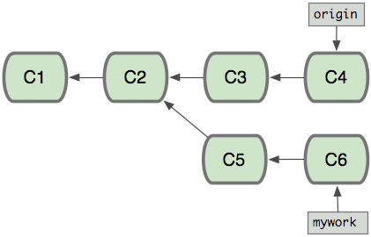
step02:
$ git checkout mywork
$ git rebase origin --interactive （交互式）
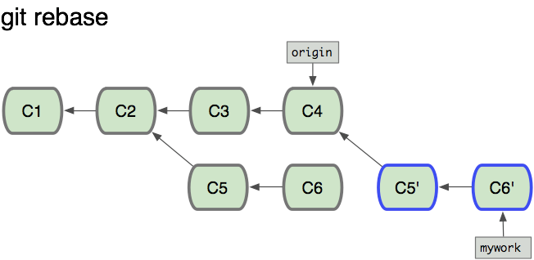
最终结果：
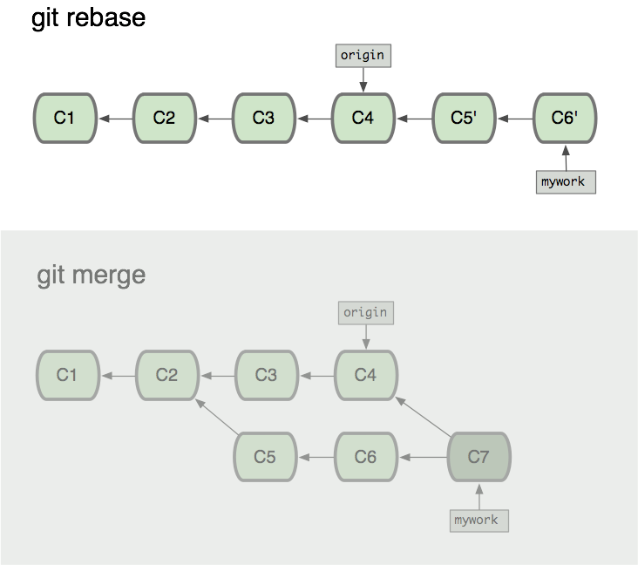
git reset
git reset --hard <commit_id> 删除错误提交的commit.

根据–soft –mixed –hard，会对working tree和index和HEAD进行重置:
git reset –mixed：此为默认方式，不带任何参数的git reset，即时这种方式，它回退到某个版本，只保留源码，回退commit和index信息
git reset –soft：回退到某个版本，只回退了commit的信息，不会恢复到index file一级。如果还要提交，直接commit即可
git reset –hard：彻底回退到某个版本，本地的源码也会变为上一个版本的内容
不加任何参数的话，就退回到当前的版本。

git tag
git tag
查看tag
git tag -d tagname
添加tag，删除tag

  - Repo
How to get repo and use?
$ curl https://dl-ssl.google.com/dl/googlesource/git-repo/repo > ~/bin/repo
$ chmod a+x ~/bin/repo

Repo is a repository management tool that we built on top of Git. It belongs to google.
You can use 'repo help COMMAND' to get the detail usage.

For reference:
http://source.android.com/source/using-repo.html#forall
    - repo init & repo sync
初始化并获取code
$ repo init -u URL [OPTIONS]
-u: specify a URL from which to retrieve a manifest repository. The common manifest can be found at https://android.googlesource.com/platform/manifest
-m: select a manifest file within the repository. If no manifest name is selected, the default is default.xml.
-b: specify a revision, i.e., a particular manifest-branch.

repo sync [PROJECT_LIST]
Downloads new changes and updates the working files in your local environment. If you run repo sync without any arguments, it will synchronize the files for all the projects.

When you run repo sync, this is what happens:

If the project has never been synchronized, then repo sync is equivalent to git clone. All branches in the remote repository are copied to the local project directory.
If the project has already been synchronized once, then repo sync is equivalent to:
git remote update
git rebase origin/BRANCH
where BRANCH is the currently checked-out branch in the local project directory. If the local branch is not tracking a branch in the remote repository, then no synchronization will occur for the project.
If the git rebase operation results in merge conflicts, you will need to use the normal Git commands (for example, git rebase --continue) to resolve the conflicts.

example:
repo init -u wanglong@192.168.1.121:29418/sony/platform/manifest -b jb-rg-internal

    - repo list
display all the project in the repository.
    - repo start
repo start BRANCH_NAME [PROJECT_LIST]
Begins a new branch for development, starting from the revision specified in the manifest.

The BRANCH_NAME argument should provide a short description of the change you are trying to make to the projects.If you don't know, consider using the name default.

The PROJECT_LIST specifies which projects will participate in this topic branch.

Note: "." is a useful shorthand for the project in the current working directory.

#From google.
    - repo status
查看所有git下的status
相当于git status
    - repo forall
repo forall [PROJECT_LIST] -c COMMAND
Executes the given shell command in each project. The following additional environment variables are made available by repo forall:

REPO_PROJECT is set to the unique name of the project.
REPO_PATH is the path relative to the root of the client.
REPO_REMOTE is the name of the remote sstem from the manifest.
REPO_LREV is the name of the revision from the manifest, translated to a local tracking branch. Used if you need to pass the manifest revision to a locally executed git command.
REPO_RREV is the name of the revision from the manifest, exactly as written in the manifest.
Options:

-c: command and arguments to execute. The command is evaluated through /bin/sh and any arguments after it are passed through as shell positional parameters.
-p: show project headers before output of the specified command. This is achieved by binding pipes to the command's stdin, stdout, and sterr streams, and piping all output into a continuous stream that is displayed in a single pager session.
-v: show messages the command writes to stderr.
- Gerrit
Web based code review and project management for Git based projects.

please refer to:
http://gerrit-documentation.googlecode.com/svn/Documentation/2.6/index.html#_getting_started
  - gerrit server setup
# create a android mirror resp
repo init -u https://android.googlesource.com/platform/manifest -b android-4.1.1_r4 --mirror

# install a gerrit server
0) preparation for pre-conditions(SMTP<SKIP>, ssh server, MySQL, Apache2)
sudo apt-get install apache2

/etc/apache2/httpd.conf

<VirtualHost *>
LoadModule proxy_module /usr/lib/apache2/modules/mod_proxy.so
LoadModule proxy_http_module /usr/lib/apache2/modules/mod_proxy_http.so
ServerName gerrit

ProxyRequests Off
ProxyVia Off
ProxyPreserveHost On

<Proxy *>
Order deny,allow
Allow from all
</Proxy>

<Location /login/>
AuthType Basic
AuthName "Gerrit Code Review"
AuthBasicProvider file
AuthUserFile /home/zhangyuz/proj/gerrit/www/etc/passwords
Require valid-user
</Location>

ProxyPass / http://localhost:8081/

</VirtualHost>

1) download the gerrit wars.
2) choose a suitable database(MySQL)

a,create a user for gerrit
b,create a database for gerrit
sudo apt-get install mysql-server-5.1
set passwd 123qwe during installation
sudo mysql_install_db
sudo mysql_secure_installation
mysql -u root -p
CREATE USER 'gerrit'@'localhost' IDENTIFIED BY '123qwe';
CREATE DATABASE gerritdb;
ALTER DATABASE gerritdb charset=latin1;
GRANT ALL ON gerritdb.* TO 'gerrit'@'localhost';
FLUSH PRIVILEGES;

3) create a gerrit user to run the www server (SKIP)
4) run the gerrit init phase
java -jar path/gerrit.war init -d path/to/somewhere

5) create the first user in gerrit
htpasswd -c /home/zhangyuz/proj/gerrit/www/etc/passwords gerrit
chmod 666 /home/zhangyuz/proj/gerrit/www/application/etc/passwords

git config --file $site_path/etc/gerrit.config auth.type HTTP
git config --file $site_path/etc/gerrit.config --unset auth.httpHeader

$site_path/etc/gerrit.conf
[gerrit]
basePath = /home/zhangyuz/proj/gerrit/src/android-mirror
canonicalWebUrl = http://localhost
[database]
type = MYSQL
hostname = localhost
database = gerritdb
username = gerrit
[auth]
type = HTTP
[sendemail]
smtpServer = localhost
[container]
user = zhangyuz
javaHome = /usr/lib/jvm/java-6-sun-1.6.0.34/jre
slave = false
[sshd]
listenAddress = *:29418
[httpd]
listenUrl = proxy-http://*:8081/
[cache]
directory = cache

Create Partition & FS on disk
1:sudo fdisk /dev/some-disk
2:follow the promopt to create new partiation
3:sudo mkfs.XXX to format the partition (you should man mkfs to get more info)

Install JDK

download JDK from Oracle

sudo mkdir /usr/lib/jvm -p

cp jdk_name.bin /usr/lib/jvm

sudo ./jdk_name.bin

export the following var to users who need java

export JAVA_HOME=/usr/lib/jvm/jdk1.6.0_45

export JRE_HOME=/usr/lib/jvm/jdk1.6.0_45/jre

export CLASSPATH=.:$JAVA_HOME/lib:$JRE_HOME/lib:$CLASSPATH

export PATH=$JAVA_HOME/bin:$JRE_HOME/bin:$PATH

  - gerrit user configuration
- Add users:
htpasswd -b /data/var/www/etc/passwords username pwd
- Add email for user
note: the email should be as same as the local in .gitconfig, or you cannot push code to server.
  - Branch manage
How to create branch for specified gits?
1. create branch in gerrit.
a. Project/Create New project (perfer to use)
b. create with git command.
2. Change the related git revision ID in .repo/manifest/default.xml.
Detail operations refer the git part.

#Pay attention to the comments style. see the examples below:
commit 1962a45c268e59878d29e53e9e12a23a3b9b42ec
Author: Jakub Adam <jakub.adam@sonymobile.com>
Date: Mon Mar 4 15:01:59 2013 +0100

Branch out 2 gits on jb-riogrande

platform/vendor/st-ericsson/hardware/libcopybit
165be4e705018e91577ac2a1511976baf6ddb07e
platform/vendor/st-ericsson/hardware/libhwcomposer
f3260304476243db6f26bb8e4498f27637f1cea2

Change-Id: I84ee445029923d1485f585ef3e009410e60fed7d
  - Change management
1. Cloning the Repository
git clone ssh://gerrithost:29418/RecipeBook.git RecipeBook
and then modify the content and commit locally.(A change-ID is need)
" Change-Id commit-msg hook will generate a unique Change-Id when you commit."

2. Creating the Review

git push origin HEAD:refs/for/master

3. Reviewing the Change

* Need Verified
* Need Code-Review

Verification is usually done by an automated build server rather than a person. There is even aGerrit Trigger Jenkins Pluginthat will automatically build each uploaded change and update the verified score accordingly.

At any time you can hit the ? key to see the keyboard shortcuts.

4. Reworking the Change

$ <checkout first commit>
$ <rework>
$ git commit --amend
$ git push origin HEAD:refs/for/master
Counting objects: 5, done.
Delta compression using up to 8 threads.
Compressing objects: 100% (2/2), done.
Writing objects: 100% (3/3), 546 bytes, done.
Total 3 (delta 0), reused 0 (delta 0)
To ssh://gerrithost:29418/RecipeBook.git
* [new branch] HEAD -> refs/for/master
5. Trying out the Change
With Gerrit’s default work-flow there are two sign-offs, code review and verify.
git fetch http://gerrithost:8080/p/RecipeBook refs/changes/68/68/2

6. Manually Verifying the Change

7. Submitting the Change

- Jekins&Build
1. Install apache
apt-get install apache2
tips: make sure the apache config file is clean.
apt-get remove apache*
apache 的配置文件：/etc/apache2/httpd.conf

2. Install Jenkins
sudo apt-get install jenkins
Jenkins home: /var/lib/jenkins
start and stop Jenkins:
sudo /etc/init.d/jenkins start
sudo /etc/init.d/jenkins stoP
sudo service jenkins stop
sudo service jenkins start
sudo /etc/init.d/jenkins force-reload
To use a nice URL, need to modify /etc/default/jenkins
adding "--prefix=/jenkins” to the “JENKINS_ARGS” section of the file.
then you can access Jenkins with "http://localhost:8080/jenkins",
unlock the firewall using: iptables -I INPUT -p tcp --dport 22 -j ACCEPT

3. Config Jenkins
Change the Home directory, for the default is "/var/lib/jenkins"
1) First, stop jenkins:
sudo /etc/init.d/jenkins stop
2) Create new home directory and move exisiting stuff from the old home to new.
sudo usermod -m -d /home/jenkins jenkins

3) Modify the config file to specify to the new home:
sudo vi /etc/init.d/jenkins
the "DAEMON_ARGS=..." line change JENKINS_HOME env to --env=JENKINS_HOME=/home/jenkins.

3. Create jobs
1) create job Using a free-style software project
2) Add the build script to the project
3) Config the build environment on the server. (Using my configuration for instance)
- copy "repo" file to JENKINS_HOME
- chgrp to "adm" group; and chown it to "jenkins" user.
- make sure the internet is connect.

4. Shell details:
How to build in personal stations?
1) Install semc-tools from sony(refer to https://wiki.sonyericsson.net/androiki/Offsite/Setup_client )
From local:
refer to http://10.80.5.70/wiki/index.php/Semc-apt-mirror
2) Make sure jenkins run in bash. and is the owner of sony code.
#!/bin/bash -ex
script...
3) How to add slaves?
- install "SSH credentials Plugin" and "SSH Slave Plugin".
- Add slave ssh-key to master.
- Create credentials in Jenkins.
- Add slave using "Launch slave agents on Unix machines via SSH" mode, add the slave IP.
- Save
- Set the time sync between master and slaves.

- For Bringup project
  - Initoalize the git repository
repo init -u git://192.168.1.108/somc/platform/manifest -b 3a314cc86e4930b3a0356c7ba67d9bfe3d09e4da --mirror
repo sync
repo init -b jb-riogrande
repo sync
git log -1 | head -n 1 | sed 's/commit //g' > HEAD_tkboy && mv HEAD_tkboy HEAD
gitgethash
#!/bin/bash
if [ "$2" == "HEAD" ]; then
cd $1
git log -1 | head -n 1 | sed 's/commit //g' >HEAD_tkboy && mv HEAD_tkboy HEAD
cd -
else
git --git-dir $1 log -1 | head -n 1 | sed 's/commit //g'
fi
find . -name repo -prune -o -type d -name "*.git" -prune -print -exec gitgethash \{\} HEAD \;
find . -name repo -prune -o -type d -name "*.git" -prune -print -exec git --git-dir \{\} branch -D jb-riogrande \;
find . -name repo -prune -o -type d -name "*.git" -prune -print -exec git --git-dir \{\} branch -D jb-riogrande-tieto \;
find . -name repo -prune -o -type d -name "*.git" -prune -print -exec git --git-dir \{\} branch -D volatile-jb-riogrande \;
find . -name repo -prune -o -type d -name "*.git" -prune -print -exec git --git-dir \{\} branch -D jb-riogrande-6.2-release \;

  - Choose the correct branch
可能是经过研究后，发现STE的STE-RG-JB-P3A 上 deliver 的 kernel 不合适，于是取以前的STE 的 deliver 版本edream6.1.1-riogrande-dtag-release 作为base
Branchout and moves freeze @ st-ericsson.git to one from ICS RG1.1.2
具体是怎么决策的？
  - manifest initialize
Sets up remotes,
gerrit
manifest-server
  - Add essential gits
It's better if CM can know every git.
we can ask architect or feature owner for help any unclear.
The essential gits are below:
semctools/sin 用于生成sin文件，使用master仓库--Done
platform/vendor/google jb-common，包涵了google官方的APP、lib、jar等--Done
platform/vendor/semc/products 直接使用edream6.1.1的仓库，即/device/semc，由于定义手机平台，后改名jb-riogrande --Done
platform/vendor/semc/build直接使用stericsson-collaboration/edream6.1.1-riogrande-release的仓库 包括了fullbuild semcsdk等 ，后改名jb-riogrande --Done
semctools/semcsystem offical build decouple-app import --Done

  - Git commit convention
Examples as below:
1)添加新仓库到项目
"Adds semcsystem.git into jb-rg-internal

semctools/semcsystem
557058d1b563a969dbf8079f3fbba1109004cc2c
"

commit 1962a45c268e59878d29e53e9e12a23a3b9b42ec
Author: Jakub Adam <jakub.adam@sonymobile.com>
Date: Mon Mar 4 15:01:59 2013 +0100

Branch out 2 gits on jb-riogrande

platform/vendor/st-ericsson/hardware/libcopybit
165be4e705018e91577ac2a1511976baf6ddb07e
platform/vendor/st-ericsson/hardware/libhwcomposer
f3260304476243db6f26bb8e4498f27637f1cea2

Change-Id: I84ee445029923d1485f585ef3e009410e60fed7d

2)给repository创建 jb-rg-internal 分支，不改变revision
"Branch out st-ericsson.git on jb-rg-internal

kernel/st-ericsson:
16e9ac15b28fb20cb6c230c6d0e175083d07b1b9
"

3)改变某仓库的静态revision
"Moves freeze in STErilOemService.git on jb-riogrande

This is fast forward jump that includes the changes
from edream6.1.1-riogrande-release in selected git.

platform/vendor/st-ericsson/apps/STErilOemService
from: 8c6cf864a36e1d93e057c2a28cbddbe720931197
to: 3894143bb450ccd40abec81834a9c808ce6a31f9
"

4)原来的revision是静态的，后既创建了jb-rg-internal分支，又改变了内容
"Branch out and moves freeze @ st-ericsson.git to one from ICS RG1.1.2

kernel/st-ericsson:
jb-rg-internal (16e9ac15b28fb20cb6c230c6d0e175083d07b1b9)
a13e3d79e56730396663a701569cb6c9e077ef50
"

5)Freeze某个仓库，即在manifest中保存静态revision
commit 0fed0938298513e1a19da16cb4eb976d45a2ed5d
Author: Sebastian Sawicki <sebastian.sawicki@sonymobile.com>
Date: Wed Mar 13 16:02:47 2013 +0100

Freeze jb-common branch of all 3 gits on jb-riogrande

platform/vendor/semc/acceptance-test-framework
ae5e56a63726d66e4356b526f86c38c162397971
platform/vendor/semc/verification/fifa
62c8060c316d4724acfdb0fcea6dc7cee0b5129e
platform/vendor/semc/verification/perceived-power
7cdde63d4527c3014ff204ceb92a4aed8c3044ff

Change-Id: I08c81af4764112862fdb40cca6fceb6a0bb097f0

